OBJECT ORIENTED PROGRAMMING (CSE -2143)

MINI PROJECT REPORT ON

**Basic Calculator**

*SUBMITTED TO*

**Department of Computer Science & Engineering**

*by*

|  |  |  |
| --- | --- | --- |
| CSE - C, III Semester, Batch:- 2022-26 | | |
| Roll.no: | Name: | Registration.no: |
| 1 | Antarip Sharma | 210905220 |
| 5 | Jeevandeep LN Shettigar | 220905016 |
| 14 | Mahika Wakankar | 220905077 |
| 17 | Princita Zina Miranda | 220905115 |

Name & Signature of Evaluator 1 Name & Signature of Evaluator 2

(July 2023 – Nov 2023)

**CONTENTS**

1. Introduction
   1. General Introduction
   2. Basic Calculator
2. Literature survey
3. Methodology
4. Results and discussion
5. Conclusions and future enhancements
6. References

**INTRODUCTION**

**1.1 General Introduction**

The calculator, a cornerstone of modern computation, has profoundly shaped how we approach mathematical tasks. Its significance lies in its capacity to swiftly execute intricate operations, rendering it an invaluable tool for students, professionals, and individuals across diverse domains. Since its inception, calculators have undergone a remarkable evolution. Early models were cumbersome and limited in function, while contemporary iterations exhibit sleek designs and advanced features, such as graphing capabilities and programmable functions. Consumer adoption has been staggering, with billions of units sold worldwide. The calculator's widespread integration into our lives has not only expedited calculations but also revolutionized industries like engineering, finance, and education. Its impact on simplifying numerical tasks is immeasurable, underscoring how this compact device has become an inseparable companion in our daily lives.

Moreover, the evolution of calculators over the years reflects a testament to human ingenuity and technological progress. From the rudimentary mechanical devices of the 17th century to the sophisticated electronic models of today, calculators have become increasingly powerful and versatile. They have adapted to meet the diverse needs of users, ranging from basic arithmetic to complex scientific and financial computations. As a result, the calculator stands as an emblem of our collective pursuit for efficiency and precision in mathematics, a tool that continues to empower individuals and drive progress in countless fields.

* 1. **Basic Calculator**

A calculator is a device designed to perform mathematical operations, ranging from basic arithmetic functions like addition, subtraction, multiplication, and division, to more complex calculations such as trigonometric, logarithmic, and statistical computations. It typically consists of a keyboard for inputting numbers and operations, a display screen to show the results, and an internal processor to carry out the calculations.

The introduction of scientific calculators equipped with functions for trigonometry, exponential notation, and statistical analysis revolutionized fields like mathematics, engineering, and the physical sciences.

In addition, specialized calculators have emerged for specific purposes, such as financial calculators for complex monetary calculations, graphing calculators for visualizing mathematical functions, and programmable calculators for creating custom algorithms.

The calculator's importance is evident in its role as a versatile tool across various disciplines, from education and engineering to finance and scientific research. Its ability to perform calculations swiftly and accurately has significantly enhanced productivity and precision in these fields. Moreover, the calculator's adaptability to different contexts and its role in aiding problem-solving have solidified its status as an indispensable device in today's technological landscape.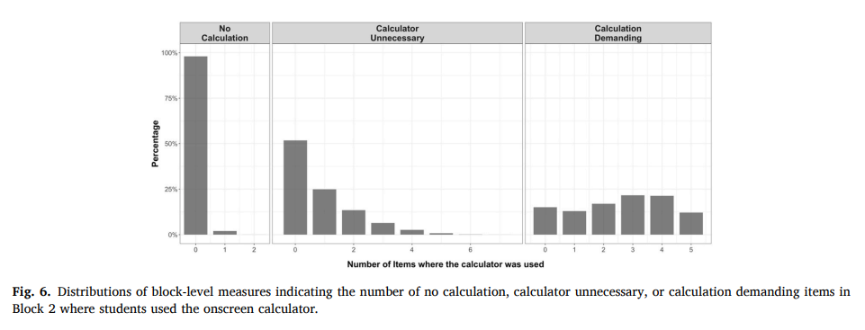

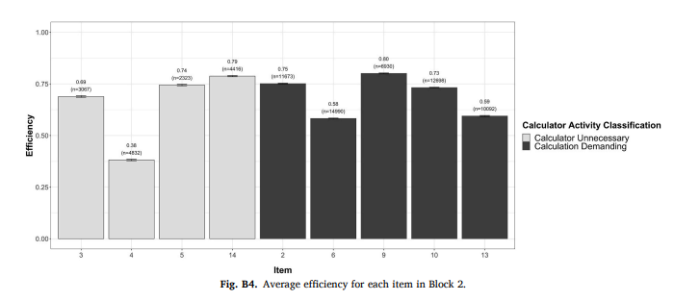

**LITERATURE SURVEY**

No specific literature was surveyed for this project, as it is a basic calculator application that primarily focuses on fundamental Java programming concepts. However, the project draws inspiration from various online JavaFX resources and documentation.

**METHODOLOGY**

**3.1 Inheritance, Interfaces, and Packages**

Inheritance is employed through the Application class, where our Main class extends it. This facilitates the reuse of code and establishes a hierarchical relationship between classes. The use of interfaces is not prominent in this project, but JavaFX inherently involves interfaces for event handling. The classes used to implement Number System Conversions also use interfaces.

Packages are utilized to organize the code modularly. The Main class is part of the application2 package, promoting code organization and reusability. The simple Invader game is placed in a separate package called Invaders, which is imported in the Main class to be used when required.

**3.2 Exception Handling and Multithreading**

Exception handling is implemented through the try-catch blocks in the convertToDouble() method, which can throw Exceptions. This ensures the program gracefully handles potential errors, such as attempting to convert a non-numeric value from the text field.

Multithreading is implemented as a way to calculate outputs on separate threads, as seen in the NumberConversion Class. JavaFX also inherently manages UI events on a separate thread, ensuring a responsive user interface.

**3.3 Generics and GUI with JavaFX**

Generics are used in the NumberConversion Class to generalize all the different number system variables into a kind of String. The use of generic data types is also prevalent in JavaFX controls, such as TextField and Button. This allows for flexibility and type safety when working with different data types.

JavaFX is used for the graphical user interface, providing a rich set of controls like buttons, text fields, and layouts. Styling and event handling are seamlessly integrated, simplifying the development of interactive GUI applications.

A simple video game application is also available in the project in the form of the SpaceInvadersApp class. This class heavily utilizes JavaFX to produce a humble gameplay experience.

**3.4 CERT Java Coding Standard**

The code adheres to CERT Java coding standards by following conventions such as meaningful variable names (tNumber1, tfNumber1), indentation, and proper commenting. This enhances code readability and maintainability.

**RESULTS AND DISCUSSION**

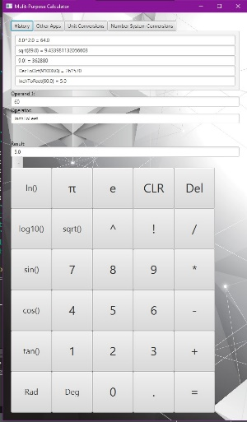

The calculator GUI successfully allows users to input atmost two numbers, and allows the user to perform a number of operations on them, as show in the figure above.

The Other Apps section in the calculator reveals the button to start the Space Invaders application.

**CONCLUSIONS AND FUTURE ENHANCEMENTS**

In conclusion, the Basic Calculator project demonstrates the practical implementation of fundamental Java concepts, providing a foundation for further exploration. Future enhancements could include additional mathematical operations, scientific functions, and an improved user interface.

REFERENCES

1. [Y Jiang](https://scholar.google.com/citations?user=MepRHRoAAAAJ&hl=en&oi=sra), [GA Cayton-Hodges](https://scholar.google.com/citations?user=O1INyuuKzCQC&hl=en&oi=sra), LN Oláh, I Minchuk - Computers & Education, 2023 – Elsevier (research paper), <https://scholar.google.com/>

2. Using sequence mining to study students’ calculator use, problem solving, and mathematics achievement in the National Assessment of Educational Progress (NAEP) Yang Jiang * , Gabrielle A. Cayton-Hodges, Leslie Nabors Olah, ´ Ilona Minchuk, <https://scholar.google.com/>